|  |  |  |
| --- | --- | --- |
|  | **BAHRIA UNIVERSITY, (Karachi Campus)**  *Department of Software Engineering*  **Assignment (2) - Spring 2023** |  |

COURSE TITLE: **Linear Algebra** COURSE CODE: **Gsc-121**

Class: **BSE-2(A&B&C)** Shift: **Morning**

Course Instructor: **Muhammad imran afridi** Time Allowed: **3 Days**

Submission Date: **6 April 2023** Max. Marks: **5 Marks**

Q1:- Find the solution set of the given system of equations by LU Factorization.

$2 x_{1}-2x_{2}+x_{3} = 1$

$x_{1}-3x_{2}+2x_{3}= -1$

$3x_{2}-x_{3} = 0$

Q2:- Find the inverse of the given matrices if possible.

$\left(i\right) A=\left[\begin{matrix}1 & -1 & 2 \\ 2 & 0 & 3 \\ 0 & 1 & 4\end{matrix}\right] \left(ii\right) B=\left[\begin{matrix}3 & -4 & 3 \\ 6 & 9 & 6 \\ -7 & 8 & -7\end{matrix}\right]$

Q3:- **The given figure show the traffic flow (Number of vehicles per minute) over several streets in Lahore Cantt at evening. Describe the general flow pattern for network.**

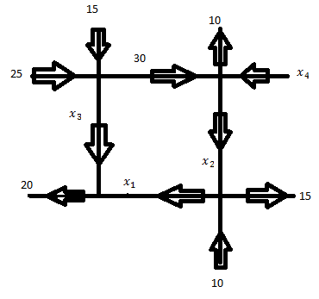

Q4:- **Show all “ $X"$ in $R^{4}$ that are mapped into the zero vector by the transformation**

$X→AX$**For the given matrix “A”**

